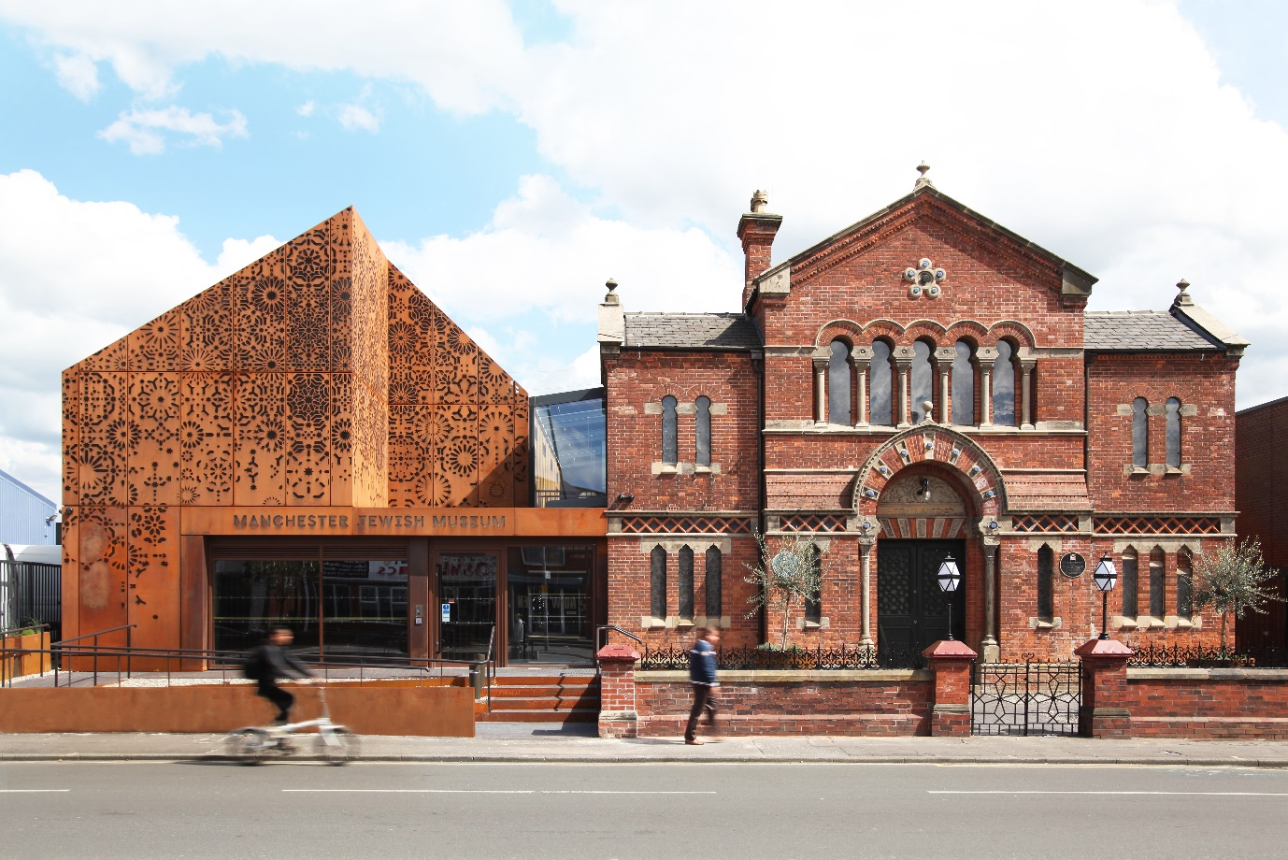

Manchester Jewish Museum exterior, image by James Houston

**JOB DESCRIPTION: Creative Producer**

**Salary:**£23,000 (pro-rata)

**Contract Type:** Fixed term contract (12 months)

**Hours:** 14 hours per week, some unsociable hours

**Accountable to:**Programmes Manager

**Accountable for:**Volunteers (supporting adult, family and school programmes)

Deadline for applications: 27th March 2025

Interviews: 1st April 2025

**ABOUT US**

Manchester Jewish Museum is common ground; a hospitable place that makes connections by showing and sharing universal experiences through the stories of one culture. We are a place to experience and explore how we are different, together. We connect Jewish stories to the world and to our society to explore both our differences and similarities, and to celebrate that which makes people unique and that which connects us all.

In doing so we look to spark reaction and change and to make real the knowledge that there is more that binds us together than separates us. We boldly explore and combine educational, cultural, and artistic experiences to encourage those with whom we come into contact to feel and believe that we are all better together.

We make connections to make things better.

We are the only Jewish Museum in the UK outside London. Our collection has been described as one of the most outstanding Jewish collections in Europe, with over 30,000 objects, documents, photographs and oral histories charting the growth of Manchester’s diverse Jewish communities, a city with the second largest Jewish population in the UK.

Since becoming an NPO in 2018 we have grown our team to deliver new and innovative programming which has resulted in a wide range of artists and communities working with us to produce a diverse portfolio of work. In 2024, we also celebrated the synagogue’s 150th anniversary, celebrating the many voices and communities who have been part of the buildings history through new exhibitions, performances and creative workshops.

Described by Arts Council England as “brave and ambitious” our programming is having a real impact, helping people connect closer to our collection and to one another. Applying the ‘scratch’ process to our work helps us support audiences to help shape and develop programming at the museum. Scratch is an iterative process, where we test out ideas on a small scale, ask for feedback, then test again, helping future proof our work.

The museum went through a £6million redevelopment, reopening in July 2021. The museum redevelopment included the addition of a gallery, café, shop and learning studio & kitchen, as well as a complete restoration of our stunning 1874 synagogue.

**CREATIVE PRODUCER ROLE**

The fundamental aim of the role is to take the lead in the production and delivery of original and innovative work for a wide range of audiences and age groups. You’ll help us to create imaginative, creative and socially impactful experiences that reflect the museum’s vision, values and programming themes. We use a ‘scratch’ process here at the museum, testing and adjusting programme experiences to make them relevant to the needs of our audiences and inviting audiences to be part of shaping our programme. The museum’s rich collection of Jewish stories sits at the heart of the programming we create, drawing on key themes of communities, journeys and identities.

You can read our Manifesto and Museum values [here](https://www.manchesterjewishmuseum.com/about-us/manifesto-values/).

**What we need you to do**

As a small team, we all lead on certain areas and support on others – planning and budgeting, press & PR, audience research, evaluation, social media, database management, etc. This role will lead on designing and delivering creative, imaginative and socially impactful programming experiences for our various audience groups.

**Key Responsibilities**

**Delivering and Developing an Engagement Programme**

* Work with the Programmes Manager to devise, manage and develop a high-quality, imaginative and socially impactful programme for adults, schools, young people and communities, scratching new ways of working whereby artists and audiences help inform programming decisions.
* Support the wider programming team with the delivery and design of family holiday workshops, school workshops, community projects and adult participatory group sessions. You’ll lead on some projects and support on others, helping other programming team members where needed and getting to work with a range of different age groups.
* Explore creative methods of bringing people together and sharing collection stories through different art forms. This might include food, conversation, art, craft and music. You don’t have to be an ‘expert’ on these art forms, but willing to get stuck in and explore creative activities with a group of people and help them on this journey.
* Support on data collection and analysis to capture impact of programming on adult, schools, young people and community audiences.
* Support with the delivery of externally funded projects to ensure that objectives and targets are met.
* Work closely with the museum’s curator to design and deliver projects that build on collection stories and connect audiences to themes within the museum.
* Collaborate with the café team to create food—based experiences that draw on stories from the collection and experiences of our communities.
* Support scratching new approaches to developing and evaluating participatory and co-created work, measuring social impact of creative and community-based engagement.
* Create programming that is embedded in the museum’s values and manifesto and draws on the wider engagement policy.

**Building partnerships and Collaboration**

* Develop and grow relationships with local partners, community organisations and the museum’s audiences to support co-creation within our programme and make sure our work is supporting the needs of our audiences.
* Build and maintain relationships with learning institutions and other arts organisations, sharing best practice and exploring opportunities for partnership working.
* Work with the CEO and Programmes Manager to embed collaborative, creative working processes (such as Scratch and co-creation) across the organisation.
* Work with staff and volunteers across the organisation to ensure programming for all audiences embodies the quality principles of originality, excellence and risk.
* Champion the vision for the creative scratch approach so that all staff, volunteers and trustees are engaged.
* Work effectively within a small team, attending staff meetings, contributing ideas, offering colleagues support and helping with the general upkeep of the museum site.
* Collaborate with artists to produce programming experiences for our different audience groups.

Administration and Support

* Manage delegated budgets and ensure all work is completed within agreed time and financial constraints.
* Work with the Finance Manager to complete all administrative tasks relating to programming.
* Support effective evaluation connected to Audience Development Plan and monitor and report on key performance indicators.
* Deliver key-holder responsibilities, including opening-up in mornings, closing in evenings, and setting alarms.
* Promote equal opportunities so that there is equality of access in the workplace and in delivering services.

**WHO WE ARE LOOKING FOR**

**ESSENTIAL**

**Experience**

• Experience of planning, managing and delivering a diverse events and activity programme within an arts, heritage or cultural setting.

• Demonstrable experience of first-hand facilitation of creative activities for a diverse range of participants and ages.

• Experience of working with culturally diverse communities.

**Skills**

• Strong organisational skills and ability to work to time constraints in a high-pressure, rapidly changing environment.

• Warm, open and confident with strong communication skills and a demonstrable ability to work successfully with a wide range of people - staff, volunteers, young people, artists, funders, partner organisations, audiences etc.

• An enthusiastic, energetic and pro-active team player.

• A commitment to ‘get stuck in’ and make things happen in a small museum with very big ambitions.

• A proven self-starter with the drive and determination to take advantage of the opportunities for development that come with this exciting role.

• Computer literate with significant experience in the use of common PC software such as Outlook, Word and Excel.

**Knowledge**

• Passionate about arts and culture, committed to the values of the museum and driven by a desire to reach new audiences.

• Ability to work some evenings and weekends.

• Strongly committed to diversity, access and inclusion.

**DESIRABLE**

• Experience of developing working in partnership with a broad range of arts and culture organisations.

• Experience of working with volunteers.

• Experience of CRM / ticketing systems

**DIVERSITY**

Manchester Jewish Museum prides itself on being a welcoming and inclusive organisation, actively celebrating diversity and promoting acceptance and inclusivity. We value the benefits that diverse perspectives bring to our work. We recognise we currently under-represent Black people, People of Colour, disabled people and those with intersecting identities in our workforce. We are actively working to address this and encourage applications from these backgrounds. While the successful candidate will be selected purely on merit, in the event of a tie between two candidates with equal experience, we may select a candidate who helps us better represent the communities the museum serves.

Design images by Citizens Design Bureau

**APPLYING**

Please apply for the above role by 27th March 2025, 9am by sending a covering letter (2 sides of A4) or a 3 minute video with an updated CV and a completed Equal Opportunities Monitoring Form to Gemma Meek, Programmes Manager.

[gemma@manchesterjewishmuseum.com](mailto:gemma@manchesterjewishmuseum.com).

If you have any questions about the above role, please contact Gemma on the above email address or telephone 0161 834 9879.

Interviews will take place on 1st April 2025 in person at the museum.